**Marcos Geraldo Braga Emiliano**

**19.1.4012**

SupMin=2;

Legenda: TID -> Lista de Itens -> Itens Frequentes Ordenados

T100 -> I1, I2, I5 -> I2, I1, I5

T200 -> I2, I4 -> I2, I4

T300 -> I2, I3 -> I2, I3

T400 -> I1, I2, I4 -> I2, I1, I4

T500 -> I1, I3 -> I1, I3

T600 -> I2, I3 -> I2, I3

T700 -> I1, I3 -> I1, I3

T800 -> I1, I2, I3, I5 -> I2, I1, I3, I5

T900 -> I1, I2, I3 -> I2, I1, I3

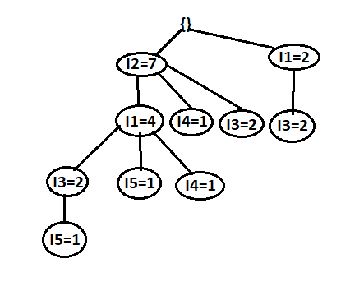

Item -> Base -> FP-Tree -> Padrões frequentes

I5 -> I2I1I3:1, I2I1:1 -> I2:2, I1:2 -> {I2,I5:2}, {I1,I5:2}, {I1,I2,I5:2}

I4 -> I2I1:1, I2:1 -> I2:2 -> {I2I4:2}

I3 -> I2I1:2, I2:2, I1:2 -> I2:4, I1:2 | I1:2 ->{I1,I3:4},{I2,I3:4},{I1,I2,I3:2}

I1 -> I2:4 -> I2:4 -> {I1I2:4}